|  |
| --- |
| Dungeon-Dash |
| 2D Platformer Game Document |
| Version 1.1 All work Copyright © 2015 by Cistronix Games. All rights reserved. Jason Huang (300818592) Oct.26th,2015 |
|  |



Table of Contents

Version History 2

Version 1.1: 3

Version 1.2 3

Version 1.3: 4

Version 1.4 4

Version 1.5 5

Version 1.6 5

Version 1.7 6

Version 1.8 6

Version 1.9 7

Version 1.10 7

Version 1.11 8

Version 1.12 8

Version 1.13 9

Game Document 9

Game Overview 9

Game Play Mechanics 9

Camera 9

Controls 10

Interface Sketch 10

Title Screen 10

The screen after Play is pressed. 10

Play can shoot at Enemies 11

The Player can Jump to avoid spikes 12

The Player collect coins 12

Game over Screen 13

Level Sketch Version 1 (On paper and paint) 13

Level Sketch Version 2 (On Tiled) 13

Game World 14

Levels 14

Game Progression 14

Characters 14

Enemies 14

Weapons 14

Items 14

Script 14

Scoring 15

Sound Index 15

Story Index 15

Art / Multimedia Index 15

Design Notes 16

Future Features 16

# 

# Version History

Project Github Link: <https://github.com/Strifez/Dungeon-Dash>

## Version 1.1:

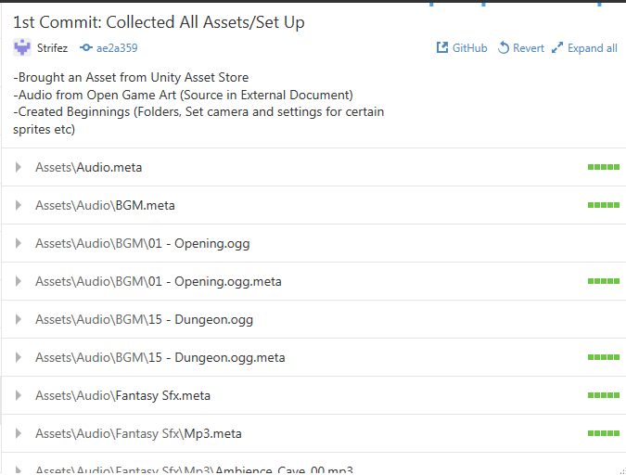

## Version 1.2

Dungeon Dash uses a program called Tiled and another program called Tiled2Unity by Seanba ([www.seanba.com/tiled2unity](http://www.seanba.com/tiled2unity)) to create the level in the game.

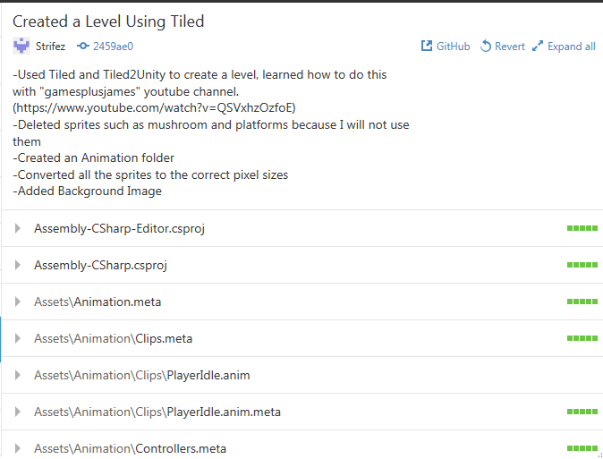

## Version 1.3:

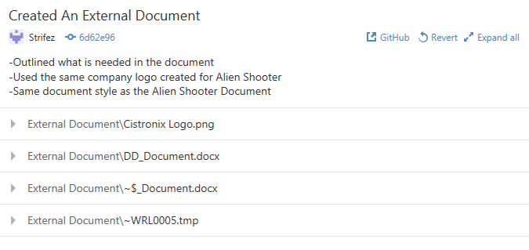

## Version 1.4

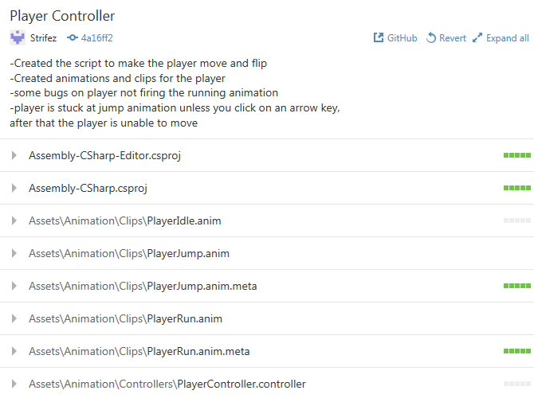

## Version 1.5

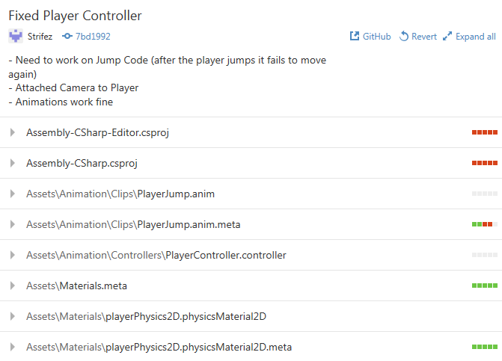

## Version 1.6

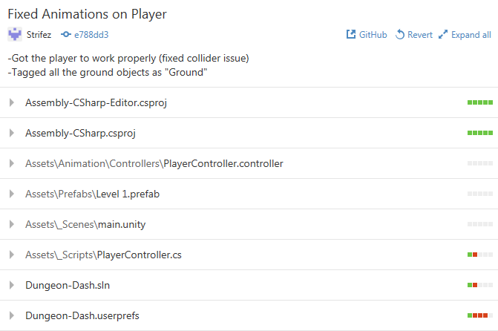

## Version 1.7

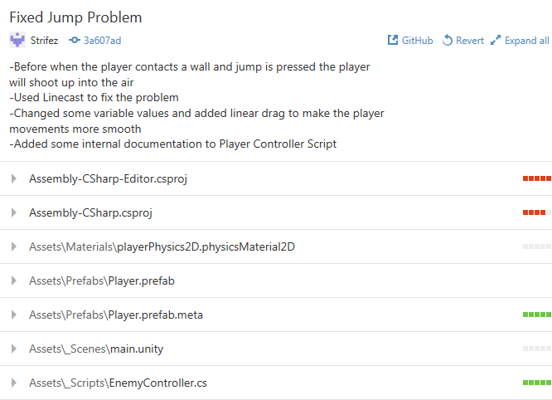

## Version 1.8

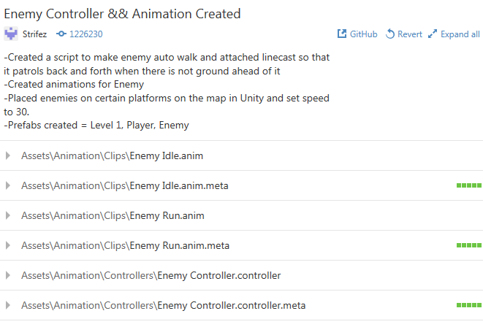

## Version 1.9

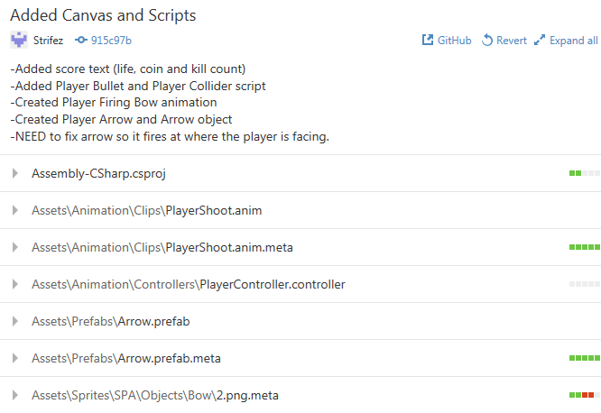

## Version 1.10

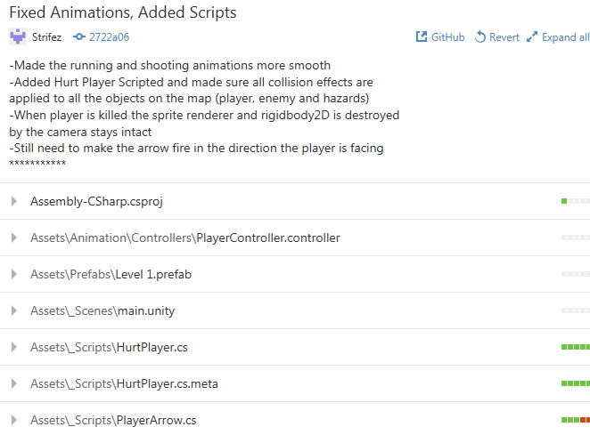

## Version 1.11

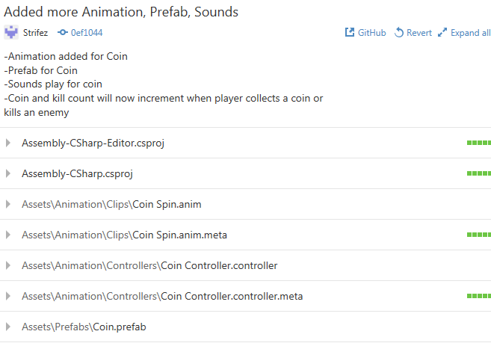

## Version 1.12

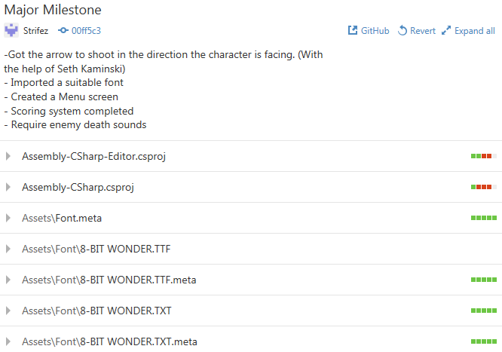

## Version 1.13

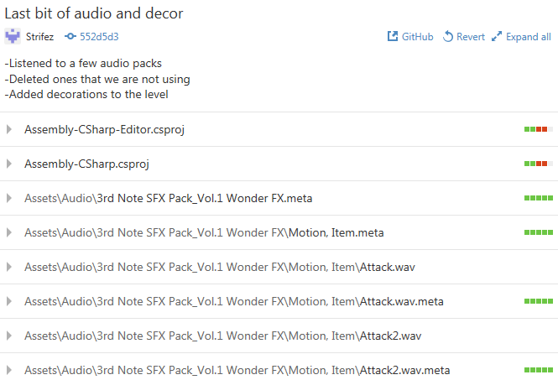

## 

# Game Document

## Game Overview

The goal of the game is to survive by killing enemies and jumping over hazards and reach the end of the level.

## Game Play Mechanics

The mechanics of the game a fairly simple, mostly jumping on platforms, over spikes, or enemies. Player is can shoot to kill the enemies but take damage when they touch hazards or the enemy. All the enemies patrol on the platform they are on and they do not shoot any projectiles at the player.

## Camera

This is a 2D platformer game and the camera is a child of the player (parent). Therefore, the camera is focused on the player. The player can move left or right to explore the level and so does the camera. The Projection of the camera is Orthographic.

## Controls

The player movements are the standard arrow keys (Down, Left, Right) and the Up key is for the jump. In addition, the space key will allow the player to shoot an arrow in the direction they’re facing.

## Interface Sketch

### Title Screen

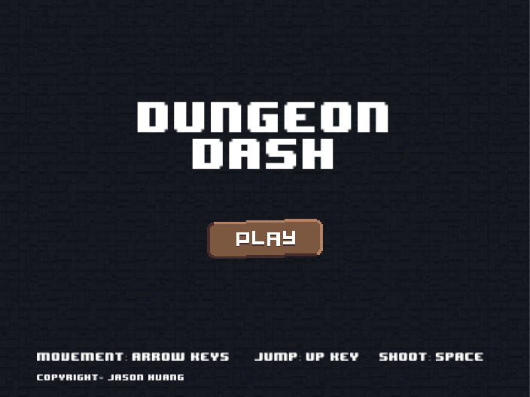

### The screen after Play is pressed.

Consists of Life counter, Coin counter and Kill counter (all incremented by 1).

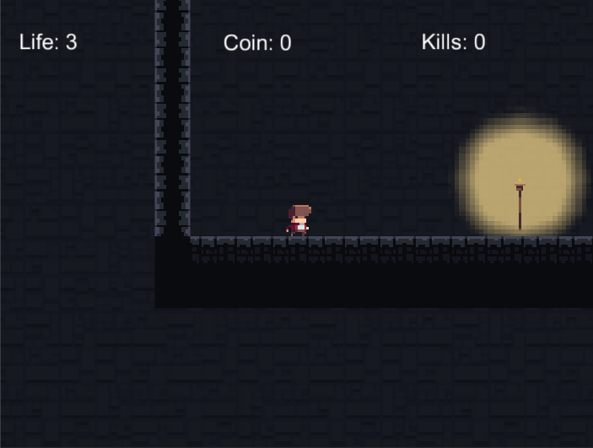

### Play can shoot at Enemies

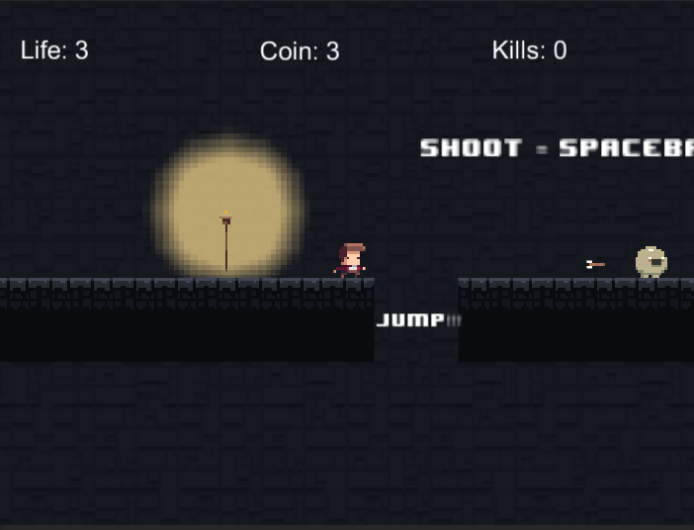

### The Player can Jump to avoid spikes

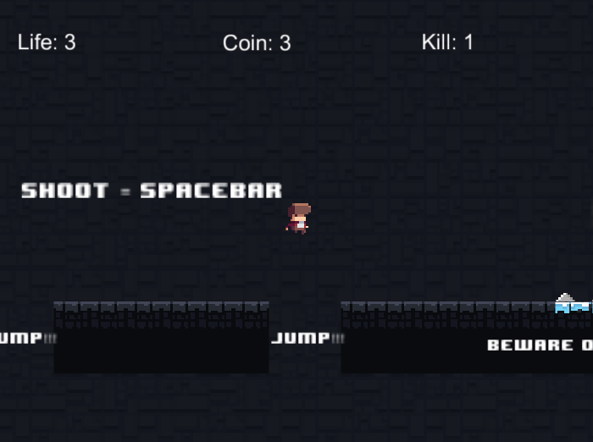

### The Player collect coins

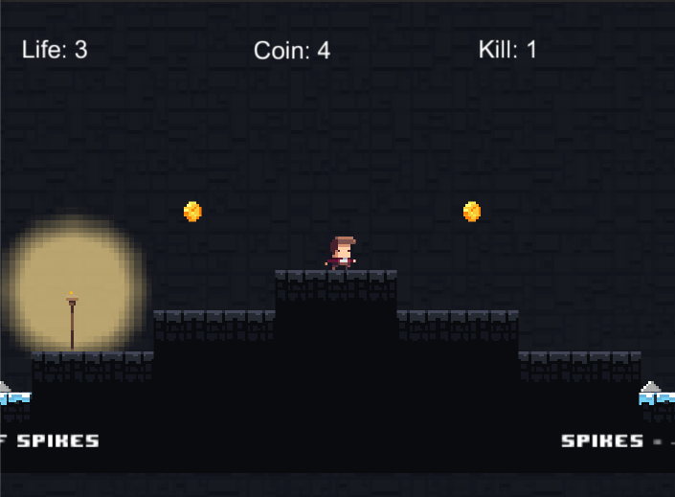

### Game over Screen

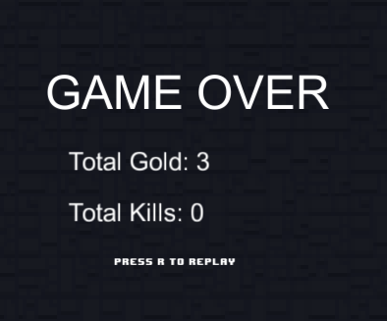

### Level Sketch Version 1 (On paper and paint)

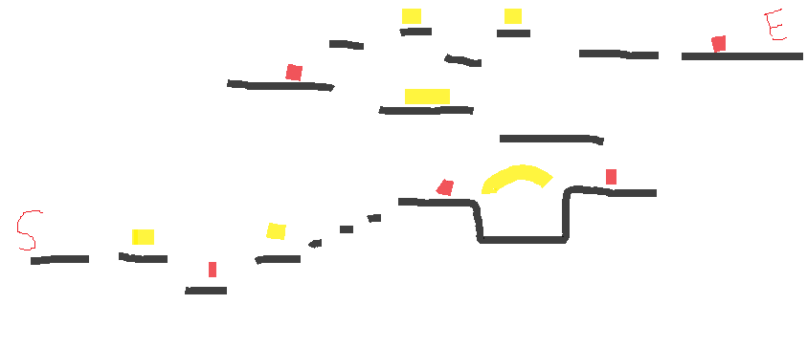

S- Start E- End Red – Enemies Yellow- Coins

### Level Sketch Version 2 (On Tiled)

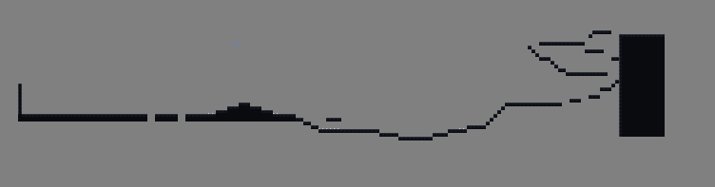

## Game World

The setting is in a dark mysterious dungeon, Buj is a treasure hunter and an explorer. The dungeon is full of surprises and dangers that waits for Buj.

## Levels

There is only one level currently; more levels will be implemented in the future versions. The first level is fairly simple and no too many enemies to deal with. The hazards that the player fights are separated in to parts. The goal of the first level is to get the player familiar with the controls and the jump distance of the character.

## Game Progression

The game progression is linear currently but when more levels which included bosses will make the game a bit more fun and challenging. The player is notified at the end of the level how to restart the game again if he/she wants to play again.

## Characters

Buj is a treasure hunter and he recently heard a rumor that there are infinite treasures found in a dungeon deep down below the surface of the ground. Buj desperately searched for the secret dungeon but all his hard efforts have been wasted when he accidently fell into a hole and fell deep underground. Little did he know, he tumbled into the cave of Infinite Treasures.

## Enemies

 Slobs are rare creatures that are rarely seen but are found to be abundant wherever there is treasure. These round creatures are usually harmless but if you touch their treasure beware they become dangerous.

## Weapons

Buj uses a bow and arrow to defend himself in case of any encounters he may face during his solo expeditions to find treasure.

## Items

Coins are regular items found in the game, and the player collects them from level to levels.

## Script

## Scoring

The scoring in the game is separated into two categories, coins and kills. Each coin the player picks up it adds 1 to the score and each player the kills also adds one to the score.

## Sound Index

Source: OpenGameArt

Background Music: by Avgvsta

<http://opengameart.org/content/generic-8-bit-jrpg-soundtrack>

Footsteps: Fantasy SFX by Little Robot Sound Factory

<https://www.assetstore.unity3d.com/en/#!/content/32833>

Ambience and Coin Sound: 8-bit SFX by Little Robot Sound Factory

<https://www.assetstore.unity3d.com/en/#!/content/32831>

Missiles and Jump: 3rd Note SFX Vol.1 by 3rd Note

<https://www.assetstore.unity3d.com/en/#!/content/43256>

## Story Index

Buj the Treasure Hunter goes around and tries to find treasure in dungeons and caves. No matter the danger, Buj will risk his life to find something unique or until he sees piles of gold. One day Buj over heard a rumor that there is a cave with infinite treasure, sparking his interest he goes on a journey to find the cave. After a very long search, Buj gives up and accidently falls down into a hole in the middle of the desert. Usually this does not concern the treasure hunter but little did he know that this was no ordinary cave.

## Art / Multimedia Index

Source: OpenGameArt

(Purchased a Sprite Pack)

Player, Enemies and TileMaps by Merve Talun

<https://www.assetstore.unity3d.com/en/#!/content/42013>

Tiled Program used to create the level by Thorbjorn Lindeijer

<http://www.mapeditor.org/>

Tiled2Unity Program used to import level into Unity by Sean Barton

<http://www.seanba.com/tiled2unity>

## Design Notes

The game was designed to have a 8-bit feel to the game. The characters and enemies were from a sprite pack by Merve Talun called Super Platformer Assets. Cistronix Games wanted to make a game for all ages and we believe that with this mysterious, fast pace 2D platformer will be what everyone wants to play.

## Future Features

Will implement other levels using Tiled and Tiled2 Unity and possibly hard enemies and bosses.